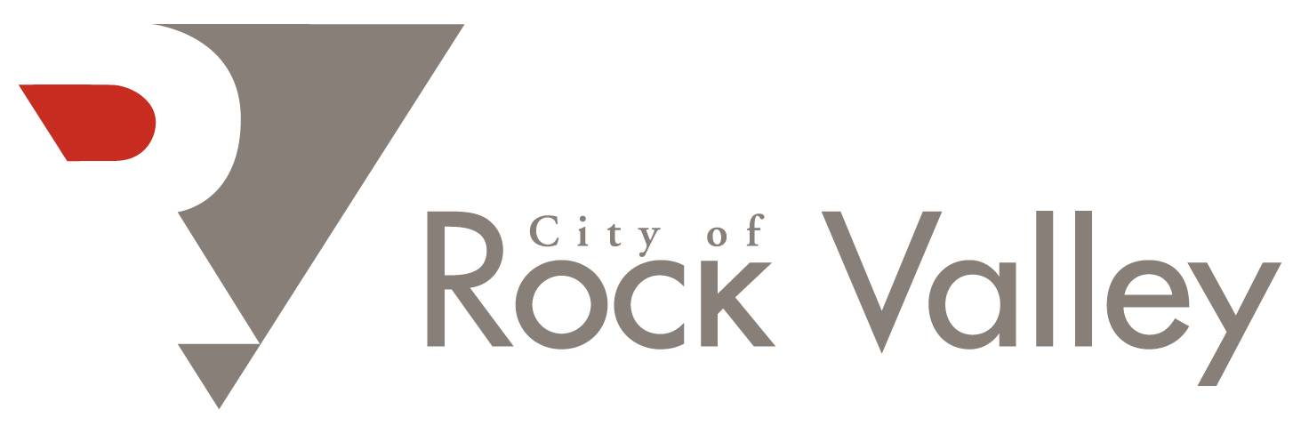

REQUEST FOR PROPOSALS (RFP)

ASBESTOS INSPECTION SERVICES

April 2, 2026

REQUEST FOR PROPOSALS (RFP)
Asbestos Inspection Services – FEMA Hazard Mitigation Grant Program Home Buyouts
City of Rock Valley, Iowa
Issue Date: April 2, 2026
The City of Rock Valley, Iowa is requesting proposals from qualified firms or individuals to provide asbestos inspection services for five (5) residential properties scheduled for demolition as part of the City’s flood recovery and hazard mitigation efforts.

1. Project Background
The City of Rock Valley experienced significant flooding in 2024 which resulted in damage to numerous residential properties. The City is proceeding with demolition of certain structures as part of its disaster recovery and hazard mitigation efforts.
Prior to demolition, the City must conduct asbestos inspections in accordance with EPA National Emission Standards for Hazardous Air Pollutants (NESHAP) and all applicable federal, state, and local regulations.

2. Scope of Services
The selected consultant will be responsible for providing the following services:
- Conduct asbestos inspections for five (5) residential structures located within the City of Rock Valley.
- Each property will be individually identified by the City prior to notice to proceed.
- Collect representative bulk samples of suspect materials as required.
- Perform laboratory analysis through a NVLAP-accredited laboratory.
- Prepare written asbestos inspection reports identifying:
  - Locations and quantities of asbestos-containing materials (ACM)
  - Material condition
  - Recommended abatement procedures if applicable
- Provide documentation necessary for demolition compliance with EPA and Iowa Department of Natural Resources (IDNR) requirements.
- Coordinate with the City regarding scheduling and access to properties.

3. Qualifications
Respondents must demonstrate:
- Certification as an Iowa licensed asbestos building inspector
- Experience conducting asbestos inspections for residential demolition projects
- Familiarity with EPA NESHAP regulations
- Ability to provide timely inspection and reporting services

4. Proposal Requirements
Proposals should include the following information:
- Firm or individual name, address, and contact information
- Proof of applicable certifications and licenses
- Description of relevant experience
- Identification of personnel who will perform the work
- Proposed fee structure, including:
  - A bid price for each individual property
  - A total not-to-exceed bid price for all five (5) properties combined
- Estimated timeline for completion of inspections and reports

5. Proposal Submission
Proposals must be submitted no later than:
April 29, 2026, 5:00 PM
Proposals may be submitted by mail or email to:
City of Rock Valley
Tom Van Maanen, City Administrator
1303 10th Street
PO Box 100
Rock Valley, Iowa 51247
Email: tomvm@cityofrockvalley.com
Phone: (712) 476-5707

6. Selection Criteria
Proposals will be evaluated based on:
- Qualifications and experience
- Ability to meet project timeline
- Cost of services
- Familiarity with regulatory requirements
The City reserves the right to reject any or all proposals and to waive irregularities in the proposal process.

7. Equal Opportunity
The City of Rock Valley is an Equal Opportunity Employer and encourages participation from qualified minority and women-owned businesses.

8. Federal Funding Requirements
This project is being funded in part through federal disaster recovery funds associated with FEMA and the U.S. Department of Housing and Urban Development (HUD). Contractors must comply with all applicable federal regulations.
To the extent applicable, the selected contractor shall comply with:
- Davis-Bacon and Related Acts (DBRA) regarding federal prevailing wage requirements
- Contract Work Hours and Safety Standards Act (CWHSSA)
- Copeland “Anti-Kickback” Act
- Section 3 of the Housing and Urban Development Act of 1968, as amended
- Executive Order 11246 – Equal Employment Opportunity
- 2 CFR Part 200 – Uniform Administrative Requirements for Federal Awards
If Davis-Bacon requirements apply to any portion of the work, the contractor shall pay workers not less than the prevailing wage rates determined by the U.S. Department of Labor for the applicable classification of laborers and mechanics.
The contractor must maintain appropriate payroll records and provide documentation demonstrating compliance with all applicable federal labor standards.

9. Compliance With Environmental Regulations
All work must comply with applicable EPA National Emission Standards for Hazardous Air Pollutants (NESHAP) regulations, Iowa Department of Natural Resources (IDNR) requirements, and any other federal, state, or local environmental regulations related to asbestos inspection and reporting.

10. Federal Contract Provisions
Because this project is funded in part through federal funds provided by FEMA and the U.S. Department of Housing and Urban Development (HUD), the selected contractor must comply with the federal requirements set forth in 2 CFR Part 200 Appendix II – Contract Provisions for Non-Federal Entity Contracts Under Federal Awards.
Termination for Cause and Convenience
The City of Rock Valley reserves the right to terminate the contract for cause or for convenience in accordance with federal procurement standards. Termination may occur if the contractor fails to perform in accordance with the terms and conditions of the contract or if it is determined to be in the best interest of the City.
Debarment and Suspension
The contractor certifies that it is not debarred, suspended, or otherwise excluded from participation in federal assistance programs as required by 2 CFR Part 180 and 2 CFR Part 3000. The contractor must verify its eligibility through the System for Award Management (SAM.gov) prior to contract award.
Access to Records
The contractor agrees to provide the City of Rock Valley, FEMA, HUD, the Comptroller General of the United States, and any of their authorized representatives access to any books, documents, papers, and records of the contractor which are directly pertinent to the contract for the purpose of making audits, examinations, excerpts, and transcriptions.
All records related to this project shall be retained for a minimum of three (3) years after final payment and completion of the project, or longer if required by federal regulations or if any audit or litigation is pending.
Compliance With Federal Laws
The contractor must comply with all applicable federal, state, and local laws, regulations, executive orders, and FEMA/HUD program requirements associated with federally funded projects.

