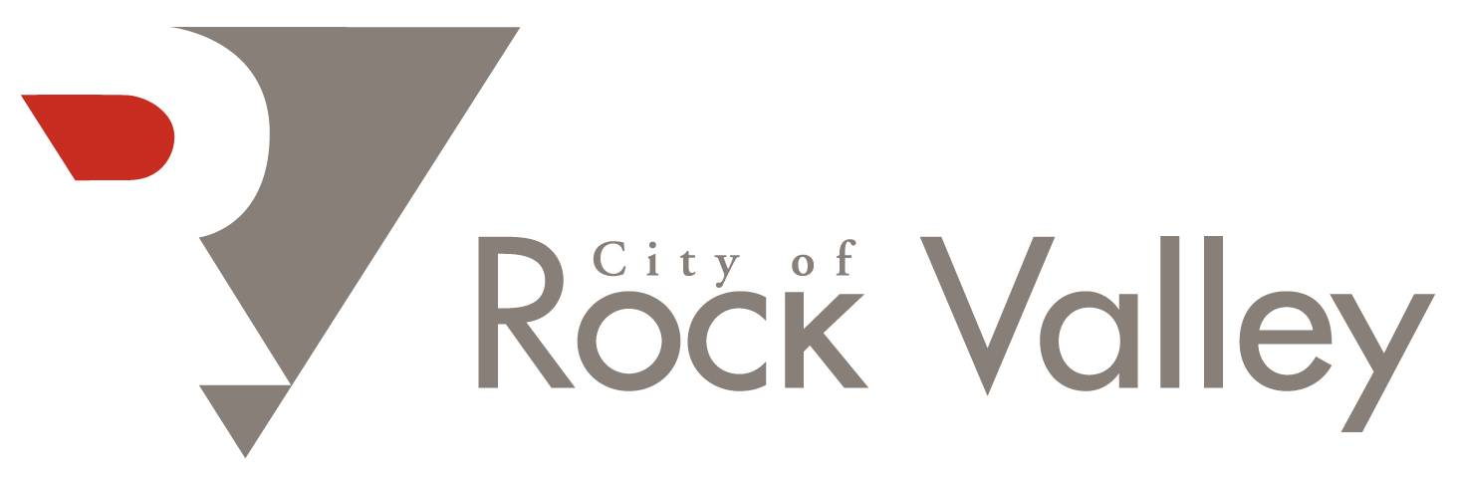

REQUEST FOR PROPOSALS (RFP)

LEGAL SERVICES FOR FEMA HAZARD MITIGATION GRANT PROGRAM – HOME BUYOUTS

April 2, 2026

REQUEST FOR PROPOSALS (RFP)
Legal Services – FEMA Hazard Mitigation Grant Program Home Buyouts
City of Rock Valley, Iowa
Issue Date: April 2, 2026
The City of Rock Valley is requesting proposals from qualified attorneys or law firms licensed to practice in the State of Iowa to provide legal services related to residential real estate acquisition under the Federal Emergency Management Agency (FEMA) Hazard Mitigation Grant Program (HMGP).

Project Overview
The City of Rock Valley has received notification that five residential properties have been approved for voluntary acquisition through FEMA’s Hazard Mitigation Grant Program following the 2024 flooding disaster. The City is seeking legal counsel to assist with the preparation and execution of purchase agreements and the closing of real estate transactions associated with these voluntary home buyouts.
The selected attorney or law firm will work with City staff, property owners, and other professionals involved in the project to ensure that all acquisitions are completed in compliance with applicable federal, state, and local regulations.

Scope of Services
The selected legal counsel will be expected to provide services that may include, but are not limited to:
- Preparation and review of purchase agreements for residential property acquisitions.
- Legal guidance to ensure compliance with FEMA Hazard Mitigation Grant Program requirements.
- Coordination with the City, property owners, title companies, and other parties involved in the transactions.
- Preparation and review of closing documents.
- Oversight of real estate closings for the five approved properties.
- Ensuring proper transfer of title and recording of deeds.
- Advising the City on legal matters related to the property acquisition process.
- Coordination and review of title work, including the ability to obtain, review, and submit title certificates or title guarantees to the Iowa Finance Authority (IFA) as required.

Federal Requirements
This project is funded in whole or in part with federal financial assistance. The selected firm must comply with all applicable federal requirements, including but not limited to:
- 2 CFR Part 200 (Uniform Administrative Requirements, Cost Principles, and Audit Requirements for Federal Awards)
- Appendix II to 2 CFR Part 200 – Contract Provisions for Non-Federal Entity Contracts Under Federal Awards
- Davis-Bacon Act (if applicable)
- Contract Work Hours and Safety Standards Act
- Equal Employment Opportunity requirements
- Debarment and Suspension (Executive Orders 12549 and 12689)
- Byrd Anti-Lobbying Amendment (31 U.S.C. 1352)
All required federal contract clauses will be incorporated into the final agreement.

Qualifications
Proposals will be considered from attorneys or law firms that:
- Are licensed to practice law in the State of Iowa.
- Have experience with residential real estate transactions.
- Have familiarity with federally funded grant programs or government acquisitions (preferred but not required).
- Demonstrate the ability to complete the work in a timely and professional manner.

Proposal Submission Requirements
Proposals should include the following information:
- Name, address, and contact information of the attorney or law firm.
- Summary of relevant experience, particularly with real estate transactions or government-funded programs.
- Description of the firm’s approach to providing the requested legal services.
- Identification of the attorney(s) who would be assigned to the project.
- Proposed fee structure (hourly rate, flat fee, or other pricing method), including:
  - A bid breakdown on a per-property basis
  - A total not-to-exceed price for all five properties combined
- Confirmation of the firm’s ability to comply with all applicable federal requirements and contract clauses.
- At least two professional references.

Proposal Deadline
Proposals must be received by the City of Rock Valley no later than:
April 29, 2026 at 5:00 PM

Proposals may be submitted by mail, email, or delivered in person to:
City of Rock Valley
Attn: Tom Van Maanen, City Administrator
1303 Main Street
Rock Valley, IA 51247
Email: tomvm@cityofrockvalley.com

Selection Process
The City will review proposals based on qualifications, relevant experience, proposed fees, and the ability to meet project timelines. The City reserves the right to request additional information or conduct interviews if deemed necessary.
The City of Rock Valley also reserves the right to reject any or all proposals and to select the proposal that it determines to be in the best interest of the City.

Questions
Questions regarding this Request for Proposals may be directed to:
Tom Van Maanen
City Administrator
City of Rock Valley
(712) 476-5707
tomvm@cityofrockvalley.com

