August 29, 2024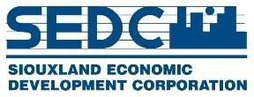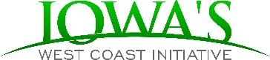

FOR IMMEDIATE RELEASE 

Contact:

Karina Pedroza

Iowa’s West Coast Initiative

Entrepreneurial Community Navigator

karina@simpco.org

402-404-4079

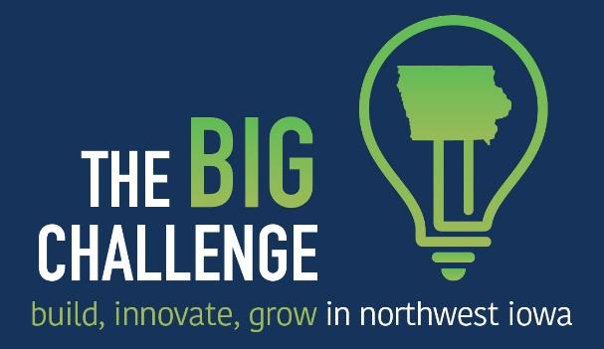

**Business Ideas Encouraged for Regional Grant Competition**

The economic development organizations in northwest Iowa are teaming up to offer $10,000 in prize money for The BIG Challenge grant competition. The **BIG** Challenge encourages entrepreneurs to **B**uild, **I**nnovate, and **G**row their business in northwest Iowa. The contest gives entrepreneurs and small business owners the opportunity to submit their dreams to start or expand a business, then encourage friends, family, and customers to vote for them online. The finalists will present their idea to an audience and judges in a pitch-off event for a chance to win thousands in cash prizes.

Now through September 29, 2024, entrepreneurs in Lyon, Monona, O’Brien, Osceola, Plymouth, Sioux and Woodbury counties can visit [www.iawestcoast.com](http://www.iawestcoast.com) and click on “The BIG Challenge” to submit their business or startup ideas.

Voting on the submitted ideas will take place October 2 through October 11, 2024. During the voting period, the entrepreneur will recruit others to vote for their entry online. The top three vote getters will advance to a regional pitch-off competition, along with two additional entrants chosen by a selection committee. Each finalist will receive personalized coaching from the University of Northern Iowa’s John Pappajohn Entrepreneurial Center.

The regional contest will be held the evening of Thursday, November 21 in Le Mars, Iowa at The Wells Visitor Center & Ice Cream Parlor (115 Central Ave NW, Le Mars, IA 51031). That evening, the finalists will have the opportunity to showcase their ideas with first place receiving $5,000, second place receiving $3,000, third place receiving $2,000 to grow their business.

The BIG Challenge is sponsored and organized by Iowa’s West Coast Initiative, Northwest Iowa Developers, and Siouxland Economic Development Corporation, which includes the economic development organizations in the following counties: Lyon, Monona, O’Brien, Osceola, Plymouth, Sioux and Woodbury. To learn about the contest rules or to enter the contest, please visit [www.iawestcoast.com](http://www.iawestcoast.com) and click on “The BIG Challenge.”